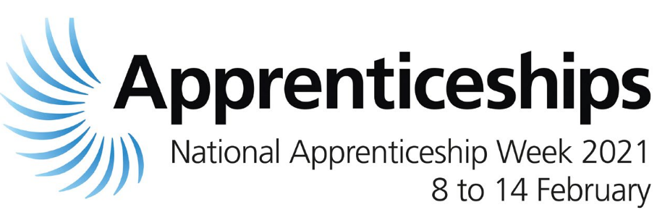

National Apprenticeship Week : 8th February to 14th February 2021

National Apprenticeship Week aims to shine a light on the amazing achievements of both Apprentices and employers across the country. The theme for this year’s week is 'build the future' and the aim is to celebrate the wealth of opportunities and value that apprenticeships bring to both individuals and employers.

During the week, Hammersmith & Fulham will be holding a series of virtual events to highlight how apprenticeships can boost your career prospects or if you are an employer, the benefits apprenticeships can bring.

- Come and meet our fantastic apprentices and hear directly about their personal journeys;

- Join our virtual careers fair and hear directly from a range of employers offering exciting apprenticeship opportunities;

- Learn how apprenticeships can act as an alternative route to education, a great way to gain employment and an earn while you learn opportunity;

- Join and participate in our question and answer panel discussions;

- If you are an employer, find out about how apprenticeships can benefit your business and hear from other businesses on the positive impact that taking on apprentices has provided for them;

We’d love you to join us during National Apprentice Week. To book click on the Eventbrite link below and complete the registration form.

Tuesday 9 February

Question time
5.00pm – 6.00pm

Live Q&A designed for residents on everything you need to know about apprenticeships

Register here:
https://www.eventbrite.co.uk/e/137959016131

Wednesday 10 February

Applying for an apprenticeship
12 noon - 2.00pm

Workshop designed to support residents with applying for an apprenticeship covering CVs/application forms/interview techniques and top tips

Register here:
https://www.eventbrite.co.uk/e/137975240659

Apprenticeship Employment Fair
6.00pm - 7.30pm

Find out about the latest apprenticeship opportunities both at H&F and with local employers.
Come and hear from our apprentices and managers about their apprenticeship experiences.

Register here:
https://www.eventbrite.co.uk/e/137979842423

Thursday 11 February

The benefits of hiring apprentices and support available to local employers
1.00pm - 2.00pm

Webinar designed for local businesses to find out about the return on investment on apprenticeships, the hiring manager experience, how to hire an apprentice and what support is available

Register here:
https://www.eventbrite.co.uk/e/why-hire-an-apprentice-tickets-138735247861

Friday 12 February

Apprenticeships in the Spotlight
10.00am - 11.15am/1.30pm - 2.00pm

Founders for Schools are hosting career inspiration webinar series in partnership with H&F.

This online event will put the spotlight on the apprenticeship community; sharing insights into how apprenticeships work as well as raising awareness around access to and benefits of apprenticeships

Register here:
https://www.eventbrite.co.uk/e/apprenticeships-in-the-spotlight-for-london-borough-of-hammersmith-fulham-tickets-137922823879

Saturday 13 February

Apprenticeship Employment Fair
11.00am - 12.00 noon

Find out about the latest apprenticeship opportunities both at H&F and with local employers

Come and hear from our apprentices and managers about their apprenticeship experiences

Register here:
https://www.eventbrite.co.uk/e/lbhf-apprenticeship-careers-fair-2-tickets-138133632413

To find out more, head to our apprenticeship pages Earn While You Learn (apprenticeships) | LBHF to find out everything you need to know about apprenticeships.

