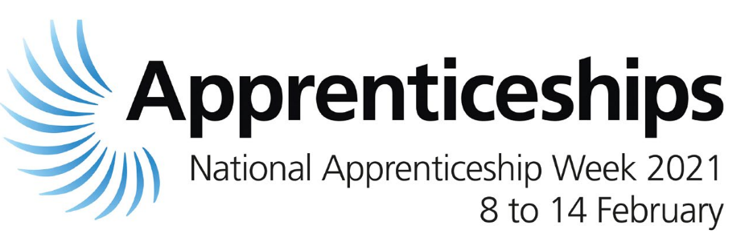

National Apprenticeship Week : 8th February to 14th February 2021

National Apprenticeship Week 2021 aims to shine a light on the amazing achievements of both Apprentices and employers across the country. The theme for this year’s week is 'build the future' and the aim is to celebrate the wealth of opportunities and value that apprenticeships bring to both individuals and employers.

During the week, we will be holding a series of virtual events to celebrate our apprentices and set out our plans to achieve even more:

- Come and meet our fantastic apprentices and hear directly about their personal journeys;
- Listen to our managers’ experiences of the positive impact that taking on apprentices has provided
- Our HR professionals will explain how apprenticeships can act as an alternative route to education, a great way to gain employment and an earn while you learn opportunity.
- Join and participate in our question and answer panel discussions
- Find out how to set up your own apprenticeship scheme or engage an apprentice.

National Apprenticeship Week is also a great way to promote learning and developmental via an apprenticeship to our existing workforce.

We believe that apprenticeships are a great way to unlock the potential of people of ALL ages and provide a route in to a successful and fulfilling career. Apprenticeships are available at many levels, from school leavers to people upskilling in their careers and complete career changes, some include a degree level qualification.

We’d love you to join us during National Apprentice Week. To book click on the Eventbrite link and complete the online form.

Alternatively, head to our apprenticeship pages Earn While You Learn (apprenticeships) | LBHF to find out everything you need to know about becoming an apprentice.

Date | Time | Theme | Summary | Hosts | Audience | Eventbrite Link
Mon 8  Feb | 1.30pm 2.30pm | All you need to know about the H&F Academy (Earn while you Learn) | Designed for H&F staff to introduce and promote apprenticeships, supported apprenticeships and supported interns | Kim Smith  Lisa Redfern | H&F  Workforce | https://www.eventbrite.co.uk/e/137911718663
Mon 8  Feb | Comms | Myth Busting | Social media comms targeted at residents - tackling common misconceptions on apprenticeships | NA | H&F Workforce  Residents | N/A
Tue 9  Feb | Comms | Celebrating our inclusive apprenticeships & supported interns | Case studies on our inclusive apprentices & supported interns | NA | H&F Workforce  Residents | N/A
Tue 9 Feb | 5.00pm  6.00pm | Question time | Live Q&A designed for residents on everything you need to know about apprenticeships | Tony Clements | Residents | https://www.eventbrite.co.uk/e/137959016131
Wed 10 Feb | 12 noon 1.00pm | Applying for an apprenticeship | Workshop designed to support residents with applying for an apprenticeship covering CVs/application forms/interview techniques and top tips | Jack Biggs  Ninar Farhat | Residents | https://www.eventbrite.co.uk/e/137975240659
Wed 10 Feb | 6.00pm 7.30pm | Apprenticeship Employment Fair | Find out about the latest apprenticeship opportunities both at H&F and with local employers  Come and hear from our apprentices and managers about their apprenticeship experiences | Kamal Motalib  Mary Lamont | Residents | https://www.eventbrite.co.uk/e/137979842423
Thu 11 Feb | Comms | An apprentice’s journey | A day in the life of an H&F apprentice | NA | H&F Workforce  Residents | N/A
Thu 11 Feb | 1.00pm 2.00pm | The benefits of hiring apprentices and support available to local employers | Webinar designed for local businesses to find out about the return on investment on apprenticeships, the hiring manager experience, how to hire an apprentice and what support is available | NA | H&F Local employers | N/A
Thu 11 Feb | 3.00pm 4.00pm | Question time | Live Q&A designed for the workforce on everything you need to know about apprenticeships | Rhian Davies | H&F Workforce | https://www.eventbrite.co.uk/e/question-time-on-earn-while-you-learn-apprenticeships-for-lbhf-staff-tickets-137930145779
Fri 12 Feb | 10.00am11.00am  1.30pm 2.00pm | Apprenticeships in the Spotlight  Future4Students career inspiration webinar series in partnership with H&F | This online event will put the spotlight on the apprenticeship community; sharing insights into how apprenticeships work as well as raising awareness around access to and benefits of apprenticeships | Jacqui McShannon | Schools | https://www.eventbrite.co.uk/e/apprenticeships-in-the-spotlight-for-london-borough-of-hammersmith-fulham-tickets-137922823879
Sat 13 Feb | 11.00am12.00 noon | Apprenticeship Employment Fair | Find out about the latest apprenticeship opportunities both at H&F and with local employers  Come and hear from our apprentices and managers about their apprenticeship experiences | Kamal Motalib  Mary Lamont | Residents | https://www.eventbrite.co.uk/e/lbhf-apprenticeship-careers-fair-2-tickets-138133632413
Sun 14 Feb | Comms | All about the H&F Academy (Earn while you Learn) | Comms article on the benefits of apprenticeships and a round-up of our National apprenticeship week events | NA | H&F Workforce  Residents | N/A

